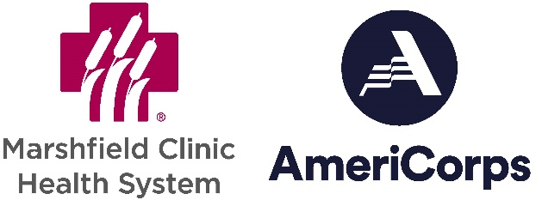

Public Notice of Non-discrimination or participants in the Marshfield Clinic AmeriCorps program:
In compliance with Corporation for National Service regulations and provisions, programs that receive federal funding, which includes Marshfield Clinic AmeriCorps, must notify service recipients, applicants, Program staff, and the public, including those with impaired vision or hearing, that it operates its program or its activity in accordance with requirements of the Americans with Disabilities Act (ADA) and Section 504 of the Rehabilitation Act. All AmeriCorps programs prohibit any form of discrimination against persons with disabilities in recruitment, as well as in service. No qualified individual with a disability shall be denied the benefits of the program, be excluded from participation in services and activities or be subjected to discrimination by the program. No person shall be denied membership into AmeriCorps by reason of race, color, creed, religion, national origin, sex, marital status, status with regard to public assistance, disability, sexual orientation or age. Veterans are encouraged to apply. It is unlawful to retaliate against any person who, or organization that, files a complaint about such discrimination.
In addition to filing a complaint with local and state agencies that are responsible for resolving discrimination complaints, you may bring a complaint to the attention of the Corporation for National Service. If you believe that you or others have been discriminated against, or if you want more information, contact:

Office of Civil Rights and Inclusiveness, Corporation for National Service

1201 New York Avenue, NW
Washington, D.C. 20525
(202) 606-7503, (voice); (202) 606-3472 (TDD)
(202) 606-3465 (FAX); eo@cns.gov (e-mail)

