Join AmeriCorps Community Corps

Earn money for college. Gain work experience. Make a difference.

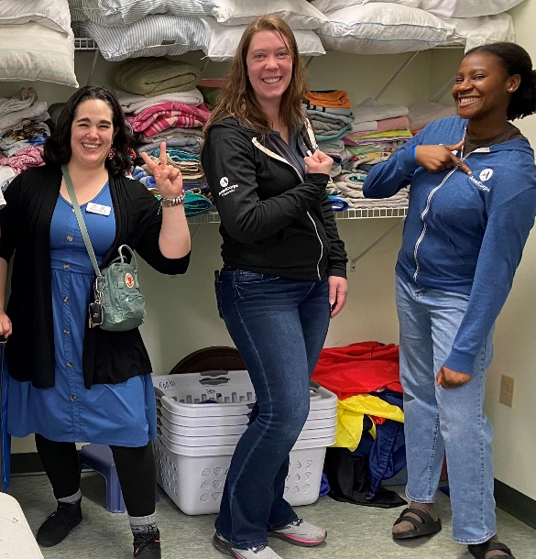
Play a vital role in tackling our communities’ most pressing challenges as an AmeriCorps Community Corps member with Marshfield Clinic Health System. Serve hand-in-hand with people at an organization working to improve health such as a non-profit, clinic, hospital, coalition, public health department, governmental agency or youth-serving organization. Your role may involve facilitating community outreach, providing health education, conducting research and analysis, offering system navigation and referrals, and other impactful activities.
Benefits of Full-Time Service  (34 hours per week minimum average) | Host sites: Please enter information about your position in this area.  Consider including:  Host site name,  Description of the position or  duties you are planning,  Weekly service hour times Mon-Fri 9-6 and some weekends (hours flexible),  Location of office,  Your contact info.
- Explore health-related workplaces and learn new skills; ideal gap-year or paid internship experience
- Make a lasting positive impact by supporting community health work
- Receive ongoing professional skills
training throughout the year to build your resume
- Earn a bi-weekly allowance of $857.69 (gross)
- No-cost health, vision and dental insurance
- Low- to no-cost child care assistance
- $7,395 educational award for tuition or student loan payback upon completing service

Open to high school graduates ages 17 and older. Applications accepted through Aug. 8, 2025
For more information or to apply, visit mchsamericorps.org
The 2025-26 full-time AmeriCorps service term is Sept. 8, 2025 – Aug. 28, 2026
