Join AmeriCorps Community Corps

Earn money for college. Gain work experience. Make a difference.

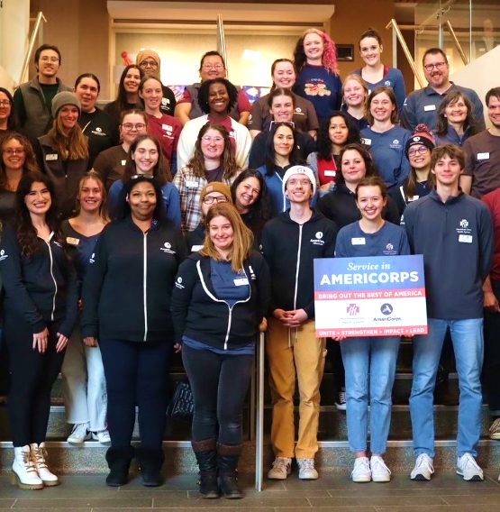
Play a vital role in tackling our communities’ most pressing challenges as an AmeriCorps Community Corps member with Marshfield Clinic Health System. Serve hand-in-hand with people at an organization working to improve health such as a non-profit, clinic, hospital, coalition, public health department, governmental agency or youth-serving organization. Your role may involve facilitating community outreach, providing health education, conducting research and analysis, offering system navigation and referrals, and other impactful activities.
Benefits of Half-Time Service  (18 hours per week minimum average) | Host sites: Please enter information about your position in this area.  Consider including:  Host site name,  Description of the position or  duties you are planning,  Weekly service hour times Mon-Fri 9-6 and some weekends (hours flexible),  Location of office,  Your contact info.
- Ideal gap year experience to explore health-related workplaces and careers
- AmeriCorps service may double as a paid internship experience
- Gain skills and experience valued by employers
- Receive ongoing professional skills training throughout the program year
- Attend school or work while serving
- Make lasting positive impact by supporting community health work
- Earn a bi-weekly allowance of $428.85 (gross)
- $3,697.50 educational award for successful service

Open to high school graduates ages 17 and older. Applications accepted through Aug. 8, 2025
For more information or to apply, visit mchsamericorps.org
The 2025-26 half-time AmeriCorps service term is Sept. 8, 2025 – Aug. 28, 202.
