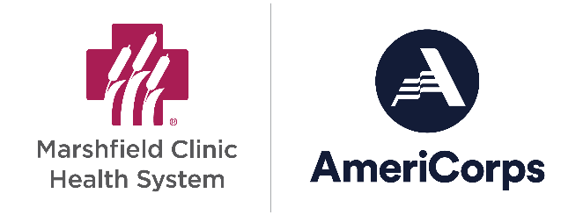
Marshfield Clinic Health System (MCHS)
AmeriCorps Community Corps
Important Dates & Details 2025-2026

Applications will be accepted through July or until all positions are filled.

September 8, 2025 to August 28, 2026 The 2025-2026 term of service; start and end dates

August 8, 2025 Member Recruitment Deadline
Applications for selected members must be submitted to MCHS by 5:00pm.

September 8-12, 2025 Member Orientation (may not require all five days, TBD)
Full days; Attendance mandatory
Location: Virtual

September 9, 2025 Host Site Supervisor Training
8:00am-12:00noon
Location: Virtual
*NOTE: Attendance for the entirety of this event is mandatory. PLEASE do not ask to come late or leave early. This is the ONLY time we have with supervisors to train them for the entire year of service. If you cannot attend the entire training, you must send a representative that can.

September 15, 2025 Member Start Date at Host Site

September 30, 2025 Member Service Plan Due
Submit to MCHS for sites with a recruited member; a unique plan per member required

November 7, 2025 Full Host Site Cash Match Payment Due

