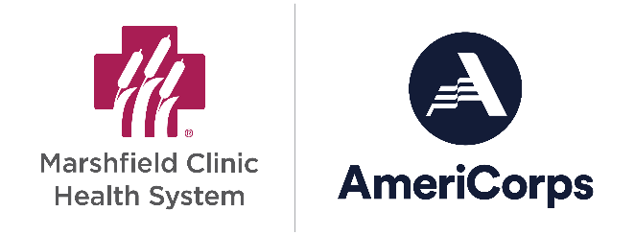
AmeriCorps Recruitment Message Tips
An ideal AmeriCorps candidate is motivated to join your program for multiple reasons.

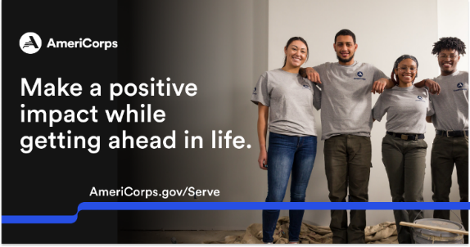
SELF - Build their resume, meet new people,
pay off student loans, etc
CLIENT - Passionate about the environment, helping kids, etc. ; they are drawn to helping the
population or cause your organization serves.
ORGANIZATION - They are aware of your
organization specifically and like it, respect it, or
want to work there one day.

Build a list of these motivations and incorporate them into your recruitment messages. Promote your position at places where people who have these motivations will already be. Find a way to stand out. Review your recruitment messages and job postings. Ask yourself:

- Did you include a strong connection to your target applicant’s wants, needs, and desires? Examples:
- Make an impact in X
- Training in X
- Education Award to pay back loans or further education
- Boost your resume
- Did you show the transformation that they could experience? What story, image, or moments can you share? Examples:
- More confidence in public speaking
- A sense of connection to the community
- Pride in making a difference
- Is there anywhere else we can be promoting? Examples:
- Local coalition
- Utilizing current AmeriCorps members
- Current or past volunteers
- Colleges or tech schools nearby – AmeriCorps can count for an internship

